**CSE 404 ( Software Engineering)**

**Assignment On Internet Of Things**

**Conducted Seminar By Grameen Phone**



**Submitted By – Submitted To –**

**Md. Feroz Mahmood Anowarul Abedin Sir**

**141014005 ULAB, Dhaka**

**CSE Department**

**ULAB, Dhaka**

Date Of Submission – 15.01.2018

Internet of Things (IoT)

The Internet of Things is a system of interrelated computing devices, mechanical and digital machines, objects, animals or people that are provided with unique identifiers and the ability to transfer data over a network without requiring human-to-human or human-to-computer interaction. IoT has evolved from the convergence of wireless technologies, micro-electromechanical systems and the Internet.

Introduction to the Cloud:

Cloud computing is typically defined as a type of computing that relies on sharing computing resources rather than having local servers or personal devices to handle applications. In cloud computing the word cloud is used as a metaphor for “the internet” so the phrase cloud computing means “a type of internet-based computing” where different services such as servers, storage and applications are delivered to an organization’s computers and devices through the internet.

IoT Architecture layers:

IoT uses a combination of Wireless Sensor Network (WSN), Machine to Machine (M2M), robotics, Internet technologies and Smart devices. In order to describe the IoT Architecture details on the Application Layer, Management Service Layer, Gateway and Network layer, and Sensor layer.

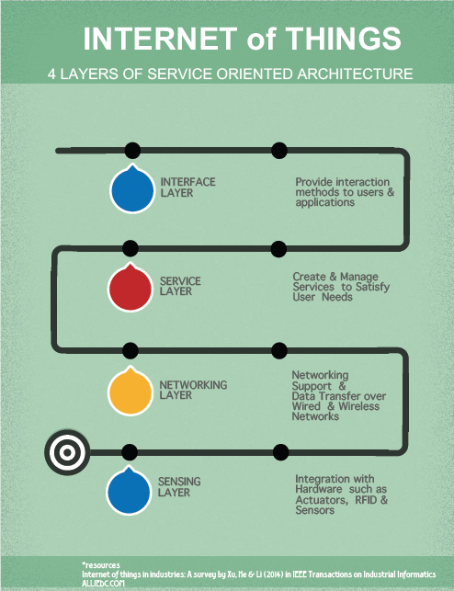

**THE END !**